
GO-STANDARD NURSERY & PRI-SCHOOLN END OF TERM III EXAMINATION 2023
BABY CLASS: (3 – 4 YEARS)
LEARNING AREA 3: HEALTH HABITS

My name is: …………………………………..………………………….
My School is: ……………………………..………….…………………..
I am in: ………………………………..………………………………………………..

- Draw these parts of the body..
mouth nose tongue

leg eyes

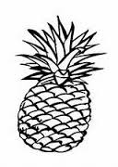
- Match and draw.
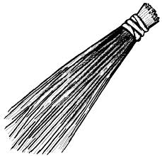

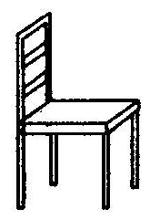
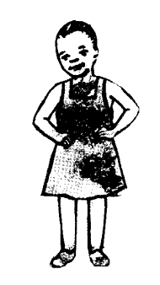

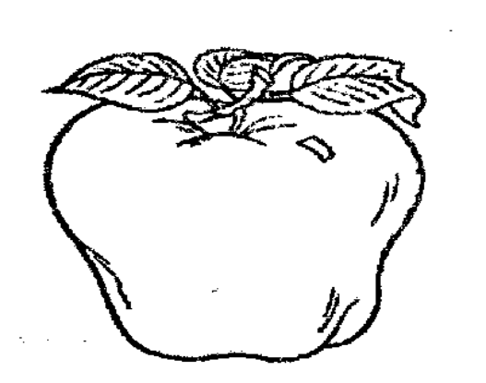

- Draw the following

tooth paste soap

water

sponge stone

- Name our foods we eat.
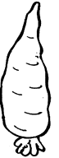
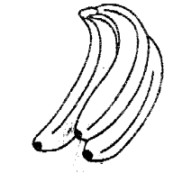

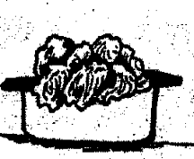
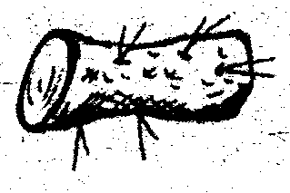

(meat, bananas, tomatoes, yam, potatoes)
- Colour the following fruits.
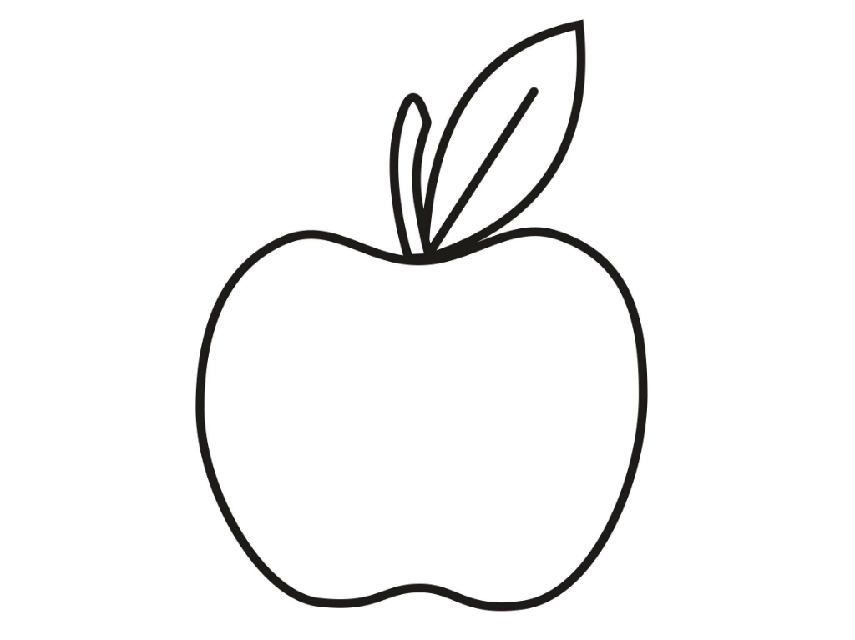
green apple

orange

“Good Luck”

